**Dealing with Uncertainty During COVID-19**

**Hold on to your ‘stability rocks’**

A ‘stability rock’ is a process or practice that adds something reliable to your life when it feels like things are spinning out of control. ‘Stability rocks’ are really grounding and help you to remember that there are some things that *are* within your control. Your own routines and rituals will become really important at this time when some parts of your life are disrupted (e.g. school, uni, work).

Some examples of ‘stability rocks’ could be:

* waking up at the same time every day
* eating regular meals
* going to bed at the same time
* doing some form of exercise every morning
* taking an afternoon tea break
* reaching out to a friend each day.

**Accept that it’s NORMAL to be feeling STRESSED**

Feeling stressed is an understandable response to the current coronavirus pandemic. You might be worried about catching the virus, about how your loved ones will cope, about the disruption to your studies and routines, and about whether you’ll still have a job and enough money. These stressors, along with the constant media hysteria and dealing with disappointment (travel bans, events being cancelled, etc.), add up to a pretty crappy time.

As hard as things are, it can be comforting to know that ***you’re not alone*** and that ***others share your feelings*.** A LOT of people are feeling stressed and anxious right now, particularly because of the uncertainty surrounding the situation. When you check in with your mates, take note of how they’re feeling – it’s likely that they’re in the same boat as you.

**Remember: you are not your thoughts!**

When you’re feeling anxious, tell yourself it’s a normal part of being human. It’s important to understand that we are not our thoughts. Thoughts may come into your head for a whole bunch of reasons. By accepting that they *are not* facts, thoughts lose some of their power to upset us.

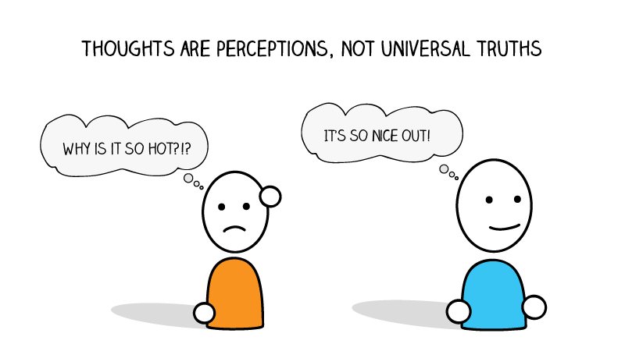Practise tolerating uncertainty, or take one day/morning/hour/moment at a time.

Predictability helps people to feel they are in control, and reassures them that their lives are settled and nothing bad will happen. On the other hand, having to deal with the unknown can make people anxious. Get a handle on anxiety by practising tolerating uncertainty. You can start by doing small things differently, such as experimenting with cooking a meal without triple-checking the recipe, or picking a random Netflix show to watch without knowing anything about it.

Write down how these behaviours make you feel (before and after doing them). One thing we don’t like about uncertainty is that if we allow it into our life, sometimes things can go wrong. To use the example of experimenting with cooking, perhaps the meal tastes pretty bad. Write down the outcome and then write down what you did to cope. For example, did you still eat the meal, or did you make something else? Maybe you sent a picture to a friend with a joke around how you #NailedIt.

Ask yourself the following questions:

* Did things turn out okay even though I wasn’t 100% certain?
* If things didn't turn out okay, what happened?
* What did I do to cope with the negative outcome?
* Was I able to handle the negative outcome?
* What does this tell me about my ability to cope with negative outcomes in the future?

The idea is to learn that even if things don’t go as planned, you can still deal with them.

**Draw on skills you’ve used before**

It’s very likely you’ve dealt with uncertainty before, and you can do it again. Reflect on what skills you have used in the past to cope with uncertainty, or ask someone who knows you well. Write a list so you have a little toolbox to refer to whenever you’re getting anxious. Your skills could include:

* focusing on what’s in your control, and working with that
* writing down what’s troubling you and what you can do to improve the situation
* practising self-care activities
* allowing yourself to take a break from what’s bothering you
* practising [positive self-talk](https://au.reachout.com/articles/3-ways-to-talk-yourself-up).



**Play to your strengths**

Working out what our strengths are, and then playing to them, can give us more confidence in times of uncertainty. Take this free [VIA Character Strengths quiz](https://www.viacharacter.org/) and then have a think about what you can do to act on those strengths. For example, if you’re creative, you could spend 30 minutes each day doing something in that area, such as drawing, playing an instrument or experimenting with a new recipe. If a value is ‘humanity’, you could practise acting compassionately and do small, unexpected things for others like checking in on a neighbour or sending a friend a song you think they’d like.

**Find ways to talk to others**

When you’re going through a tough time, one of the best and most effective things you can do to feel better is to talk with someone. If an in-person meeting isn’t possible,

organise a time to call, text, WhatsApp, Skype, Google Hangout, Slack Video or Zoom. When you talk to a trusted friend, family member or health professional, tell them what’s stressing you out and why. They may not have all the answers, but just sharing what you’re going through can help get it out of your head and make it feel less scary.

**If you feel overwhelmed, seek support**

Sometimes things can get overwhelming, even if you’ve been practising these skills. As most people will be physically distancing or self-isolating, a great option is telephone and online services. Lifeline (13 11 14) and Kids Helpline (1800 55 1800) can be accessed for phone and online counselling, with Lifeline phone counsellors on call from 7 pm to midnight, and Kids Helpline available 24/7. [Eheadspace](https://headspace.org.au/eheadspace/) also offers free online and telephone support and counselling.

If it’s available to you, you could consider seeing your GP or mental health professional for extra help (but make sure to follow the advice of [Healthdirect](https://www.healthdirect.gov.au/coronavirus-covid-19-seeing-a-doctor-getting-tested-faqs) if you’re showing symptoms or are in self-isolation). You could also ask your mental health professional if they could chat over Skype/FaceTime if you’re in self-isolation.